**Create Credentials for Google Cloud Services**

If you don’t have Client ID and Client Secret in Google Cloud and relevant service API is not enabled in the services, then go to <https://console.cloud.google.com/> for the configuration. Following window will appear.

* Click on **Select a project**.

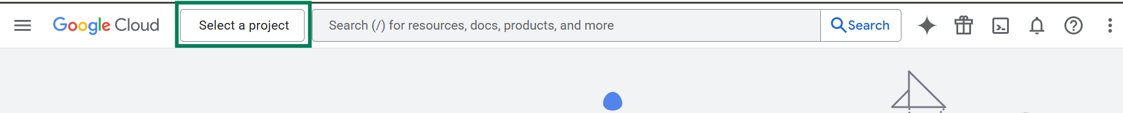

* Click on **New Project**

* Fill in the required information and click on **Create** button.

A billing account will be required to proceed with the services.

* Check whether the correct project is selected or not.

* Select **API & Services**.

* Go to **Enabled APIs & Services**.

If you go to the bottom of the page, you will see the list of enabled services.

* Search required service name. Here, we will use Google Drive as an example. Select **Google Drive API** from the list.

* Check if Google Drive API is enabled or not.

* If API is disabled, click on **Enable** button to enable it.

Follow the same procedures for enabling any service API.

* Go to **Credentials** now.

* Click on **Create Credentials**.

* Select **OAuth client ID** from the list.

* Fill in the information as follows:

* Copy following URL from N8N window and add it here. Click on **Save** button.

* Once the credentials are created store it in a secure location. You can’t retrieve the **Client Secret** later from the console.

You have successfully created the credential for Google Cloud Services.